Renju lesson on July 19, 2001
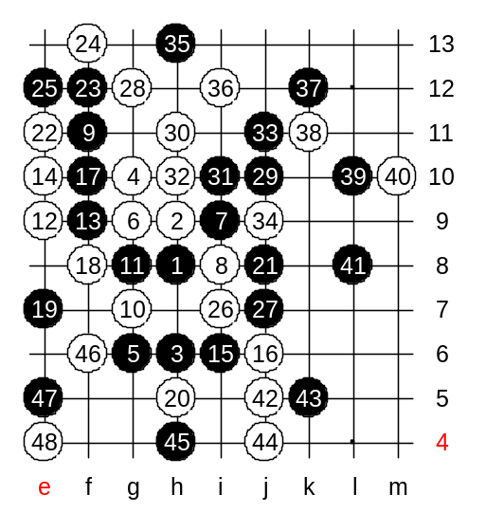
Hello all! Welcome to Online Renju Class.
There are some short announcements to make:
Our renjuclass will go to vacation after July 26. We will rest in August and come back in September. Soon we will open our game server at renjuclass.com. Then you can enjoy playing renju games during the vacation period.

Lets begin the lesson now. We will continue the game that we started last week. Most of you are familiar with the position. We have 48 stones on the board. It is student’s turn to move. I wish you all luck in the game. Heroabro will count the votes. You will have 2 minutes to discuss each move. Remember, you must vote once on every move in orter to prove your active participation.

Move 54 – a tricky one. Threats to catch the beautiful 4x4. However, one black stone is bothering the win. So white cannot win above.
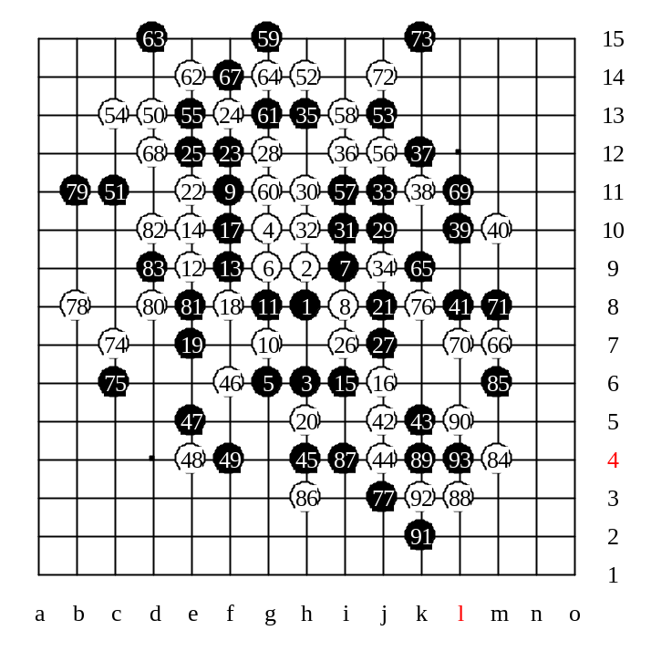
White keeps attacking, but it is hard to win because of small space.

The tough game finally ended with draw. It was a very good game.

My comments to the game:

The opening variant was new for all of us. There has not been any serious analysis about it. It seemed black didn't choose good plan. But moves 17 and 19 were simple and good. Previously I had mentioned that the 12th move is loss, and black has sure win there. But you choose weak 13th move. Then, my weakness was, I tried to give too much pressure on position with straight moves 30 and 32. That was bad. I guess I should have just blocked black structures directly and keep the space and white material open. In WC games I would have chosen that plan because I cannot gamble there. 22-e11 was just an exchange of moves, didn't influence much. In fact, it blocked black connections over left side. Later on, move 36 was not good either.
As civsnail posted in message board, black might use a brave style, and get a promising position. Most of your moves were good, or at least solid. There were some weaknesses where you defended by luck. But that is part of the renju game.
Move 69-L11, last serious block. After that white chances to win were minimal. Otherwise, the point L11 was under attack, might have become 4x4. So after you took that point, the game was very much draw.
You all did a very good job.
And it was great to see that the majority of you always followed the reason and made wise moves. I made the mistake with move 30. That probably gave you the draw.

